WRITE A PROGRAM

<HTML>

<TITLE>UNORDERED LIST</TITLE>

<BODY>

<H1>COMPUTER COURSES</H1>

<H1 STYLE=COLOR: RED>GNA</H1>

<UL>

<LI STYLE=COLOR:RED>MOUSE</LI>

<LI STYLE=COLOR:ORANGE>KEY BORAD</LI>

<LI STYLE=COLOR:GREEN>PC </LI>

</UL>

OUTPUT

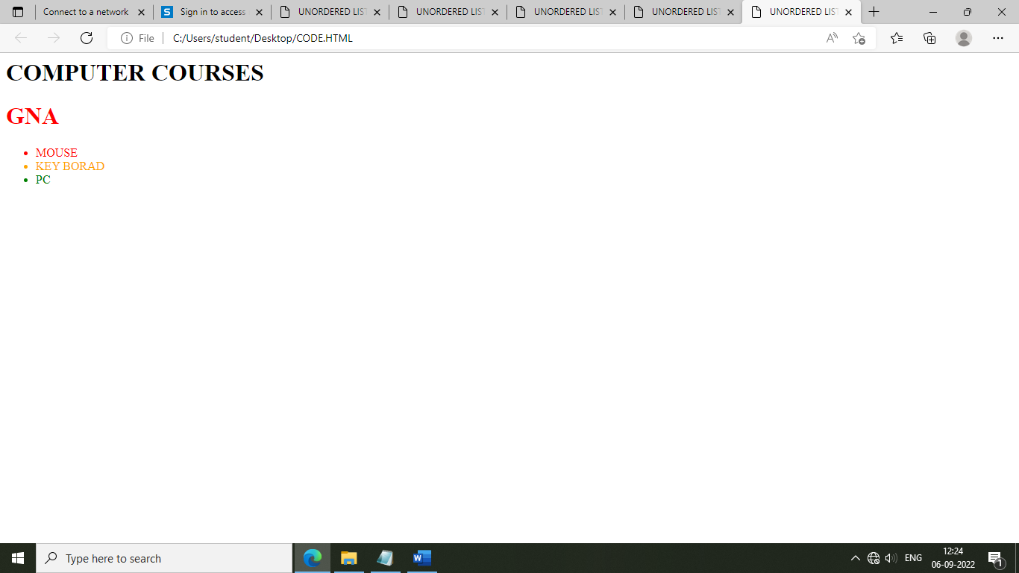

<HTML>

<TITLE>UNORDERED LIST</TITLE>

<BODY>

<H1>COMPUTER COURSES</H1>

<H1 STYLE=COLOR:RED>GNA</H1>

<OL>

<LI STYLE=COLOR:RED>MOUSE</LI>

<LI STYLE=COLOR:ORANGE>KEY BORAD</LI>

<LI STYLE=COLOR:GREEN>PC </LI>

</OL>

